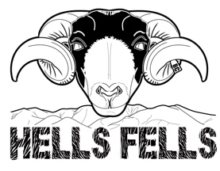 | Entry Form | 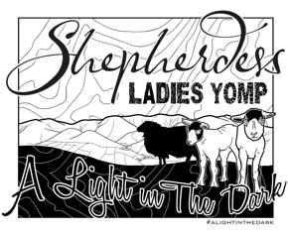

 | Name |  |  | Team Name (if known)
 | Email |  |  | Tel No.
 | Ability (Please Tick) |  |  | In Case of Emergency Contact
 | Beginner
 | Intermediate
 | Advanced
 | Please list any medical conditions
 | Special dietary requirements
Please send to: Ladies Yomp, Birks Farm, Birks Lane, Sedbergh, Cumbria, LA10 5HQ

